

**OFFICE OF THE PRESIDENT**

**DATE :** May 30, 2020

**TO :** All Concerned

**SUBJECT : THE VIRTUAL USJ-R**

For your reference, we are forwarding to you “The Virtual USJ-R: Guidelines, Netiquette Rules or Etiquette in the Internet, and Rules in Joining Virtual Meeting” your information.

Thank you for your attention and cooperation.

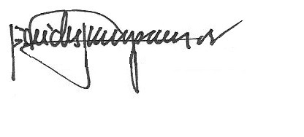

REV. FR. CRISTOPHER C. MASPARA, OAR

University President

/bvs

Attachment’